Unit 1 Project Approaches

**Corey Crooks**

**Purdue University Global**

**IT401 Project Management II**

**Steven Long**

**September 27th, 2023**

Project management involves many moving pieces that can be difficult to fully coordinate. These moving pieces have many stakeholders, project leads, and team members associated with them that may or may not be utilized to the fullest extent at all timelines in the project. How is one to maximize efficiency with a project in a technical degree? If the team roster includes quality assurance, how are they to work effectively before the development team has completed a complete testable product?

One way of accomplishing team efficiency would be through an agile approach and discipline. During an agile approach, work is debuted into smaller modules that the team may process concurrently to ensure less “down-time” for associated team members (Project Management Institute, 2021). In the above example the development team may work on a section of a program like the user data inputs, for instance. This project development approach typically deals with dynamic workloads in which requirements and deliverables are constantly updated throughout the lifetime of the project being developed. To this end, each member of the team works to provide a more adaptive workflow compared to other disciplines.

This is not the only development approach to project management, however. Another approach deals with potential volatilities in the agile development means. Predictive Project Management, or a Waterfall approach, aims to make the entire project as outlined and static as possible (Project Management Institute, 2021). Because of this, elements like project scope, requirements, and deliverables are all to be discussed and negotiated before modules are completed (Oguz, n.d.). This will ensure the team understands exactly what is happening, and what to work forward to. A hybrid approach combines these two development ideologies into a single, condensed focus. This takes the strengths of adaption from an agile development with the rigidity and structure in scope from predictive management to create an environment that is capable of needed change, but remains solid enough for long-term structural coherence.

As mentioned, there is no single answer for all project solutions. Each approach comes with unique strengths and weaknesses that must be identified and analyzed before the approach is applied to a particular project (Project Management Institute, 2021). There are many factors to consider when choosing an approach. Rigidity of the project is paramount to certain approaches, for instance. If project requirements are unknown, it may be best to try an approach that remains adaptive for uncertain circumstances (National Academies Press of Washington, DC, 2004). If there is only one delivery by the end of the project, then it may be unwise to choose an agile approach, as that is best suited for smaller chunks of processable modules. Another factor to consider is that of risk. If a project is prone to failure, it may be wise to consider something with more structure such as a predictive approach to compensate for known issues that may arise during development.

**Chosen Project Outline**

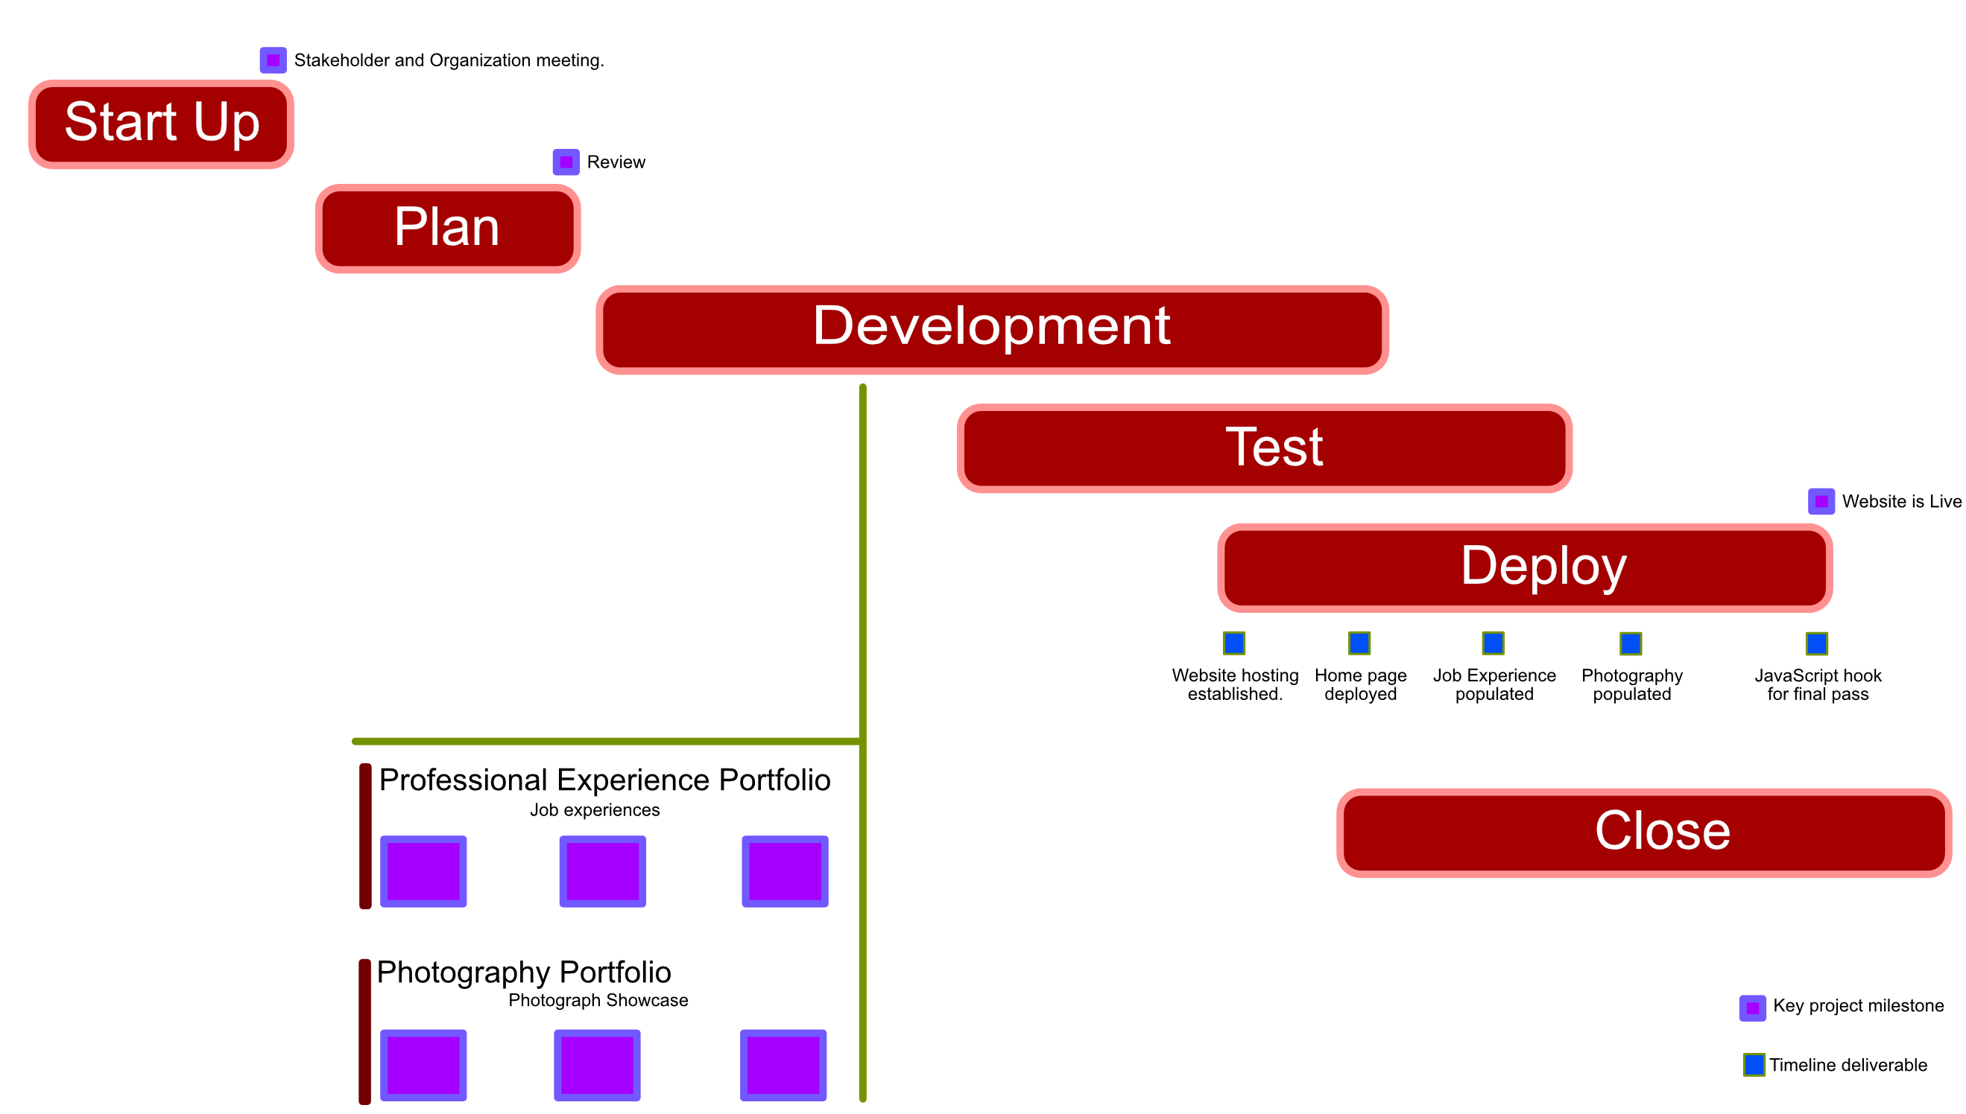

The above diagram lists a project I have recently worked on. This is building a portfolio website to host my professional experience, as well as my photography. This project dealt with many modules that needed to be developed one-at-a-time in order to ensure the entire project is successful. To do this, it was best to deploy an agile approach. The diagram illustrates a lifecycle for this project using that mindset. In order to complete this project efficiently, the delivery cadence needed to include multiple deliveries as sections of the website would be developed, tested, and deployed.

# **References**

National Academies Press of Washington, DC. (2004). *Adaptive Management for Water Resources Project Planning*. Retrieved from nap.edu: https://nap.nationalacademies.org/read/10972/chapter/4

Oguz, A. (n.d.). *Chapter 12. Agile (Adaptive) Project Management*. Retrieved from Project Management Navigating Complexity: https://pressbooks.ulib.csuohio.edu/project-management-navigating-the-complexity/chapter/12-1-introduction-to-agile/

Project Management Institute. (2021). *A Guide to the Project Management Body of Knowledge (PMBOK® Guide) – Seventh Edition and The Standard for Project Management (ENGLISH)*. Retrieved from EBSCO: https://eds-p-ebscohost-com.libauth.purdueglobal.edu/eds/ebookviewer/ebook/bmxlYmtfXzI5NDI0MjlfX0FO0?sid=53688938-468d-40ec-89ef-c15aa3a21a77@redis&vid=1&format=EB&rid=1